Data for Accountability, and Impact Monitoring (DATIM)

Data Import App Guide

Sept 2022

U.S. Department of State
Office of U.S. Global AIDS Coordinator and Health Diplomacy (S/GAC)

Table of Contents
About Data Import App 1
Getting Started 1
Results File Format and Content 1
Step-by-Step Guide to the Data Import App 3
Step 1. Login into GeoAlign 3
Step 2. Importing Results File for Validation 4
Step 3. Review and Resolve Validation Issues 5
Step 4. Review Import Count 6
Step 5. Import Data into GeoAlign 7
Step 6. View Import Details 7
Step 7. Enter Narratives Data 8
Step 8. Approve Submission for DATIM 8

DAA Import App Guide
This document defines the requirements for creating and importing the Results File, which will contain the Ministry’s annual results for the relevant indicators per facility.

About DAA Import App
The DAA Import App was developed to allow users to upload and validate a result file, enter narratives for MoH indicators, approve the validated file for import into GeoAlign and later into DATIM. It simplifies the data submission process and can be access from a browser anywhere the internet is available. Additionally, you can download multiple files/ reports once the file is uploaded and processed. These includes:
- The uploaded Result File
- Results Summary Table Report
- Mappings for Indicators Report
- Transformed Site-level Data Report

Getting Started
Before you begin, you must have completed and successfully reconcile your facilities and mapped your FY22 indicators and created your results file to upload.

Results File Format and Content
The results file must be formatted as a Comma Separated Values (CSV) document using a flat-file structure. The file must consist of at minimum the following column headings below:
- MOH_Facility_ID: This column stores the MoH’s unique identifier for facilities which was defined during the Facility Reconciliation exercise. For more information on facility reconciliation and the tools used during this process, please visit - Activity Components: Facility Reconciliation.
- MOH_Indicator_ID: This column stores the MoH’s indicator code which was defined in the Indicator Mapping exercise. For more information on mapping indicators and the tools used during this process, please visit – Activity Component: Indicator Mapping.
- MOH_Disag_ID: This column stores the MoH’s disaggregation code, as defined in the Indicator Mapping exercise.
- Value: This column stores the MoH’s numerical result value of the respective indicator and facility, accounting for a full 12 consecutive month cycle, as specified by the period.
- Period: This column stores the reporting period for which the results are being submitted for.

Important: - The reporting period must align with that of the COP21/FY22 reporting period which begins October 1, 2021 and ends September 30, 2022. The period must be in entered in the format of YYYYMMM e.g. “2021Oct”.

Important: The order of the five fields above is not essential, but the header names need to match the five field headers as listed above. Changes to the header name will cause errors when importing.
This example demonstrates the first four lines of the Results File as seen in MS Excel:

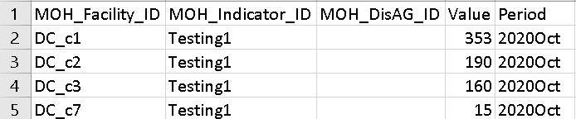
Here are the first four lines of the Results File as seen in a generic text editor:

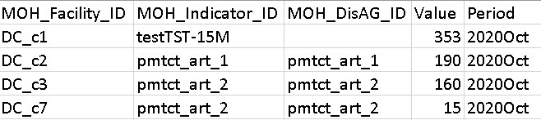
The figure below demonstrates the names (in Columns F, G, and H) to help you better understand the IDs. You do not need to include the name fields in the results file.
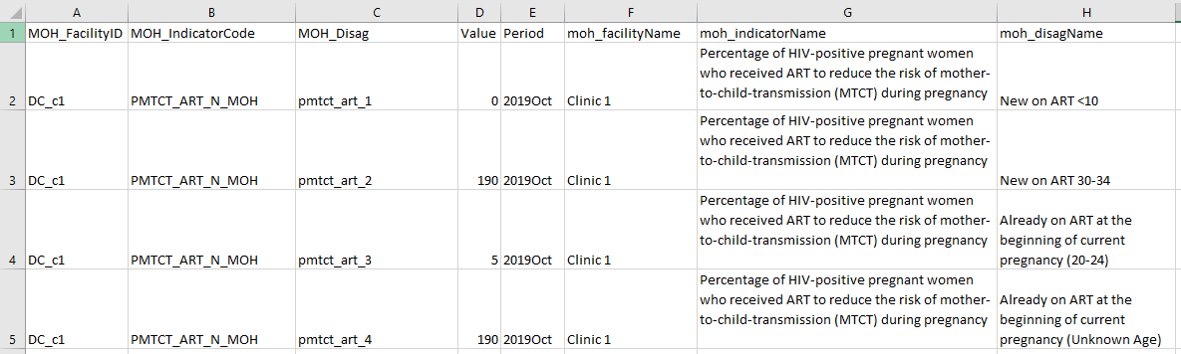

Step-by-Step Guide to the DAA Import App

Step 1. Login into GeoAlign
To access the DAA Import app, you will need to have access to GeoAlign (https://geoalign.datim.org/). If you do not have access, please submit a request to the DATIM Support team at https://datim.zendesk.com/hc/en-us/requests/new. Once you have access to GeoAlign, please login using your username and password.
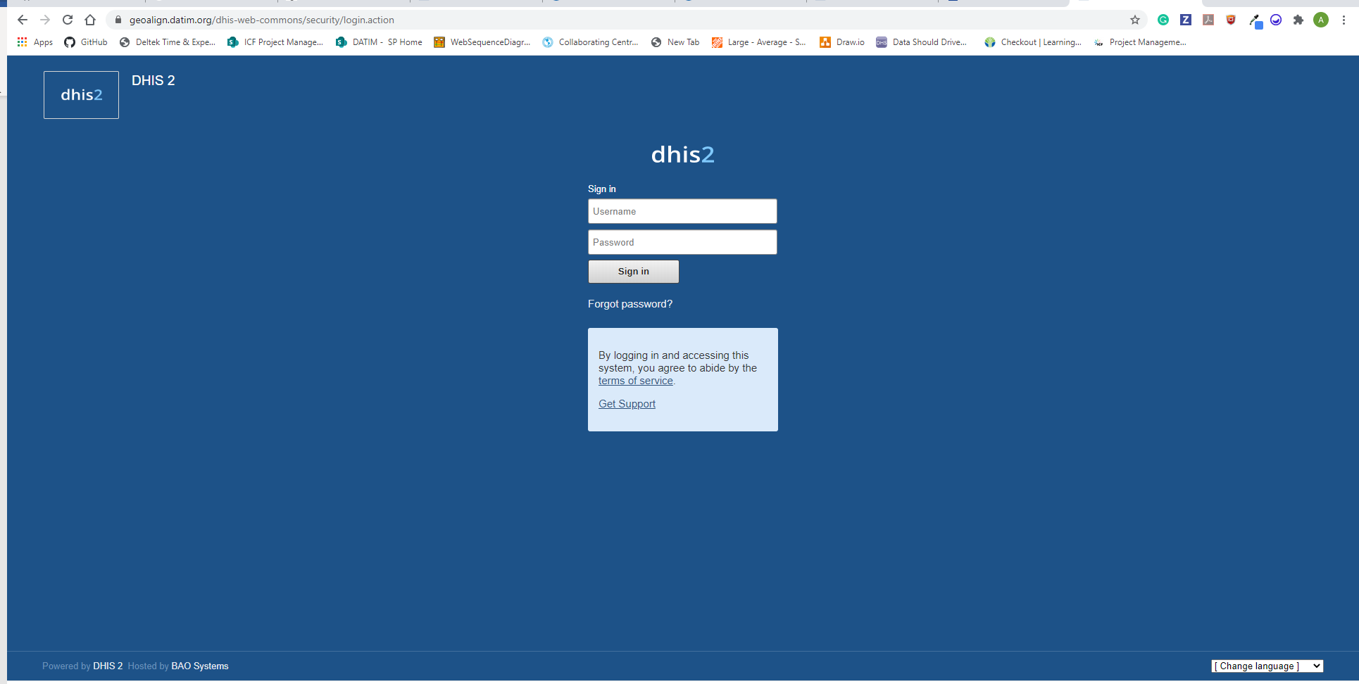
Search for the DAA Import App using the ‘Search apps’ icon in the menu bar and select the app.
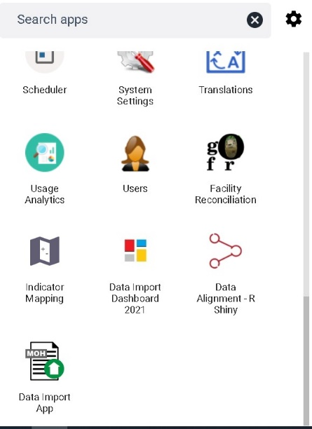
The app defaults to the page below where you can select the period you would like to submit results for, view previous imports, and the results of those imports.

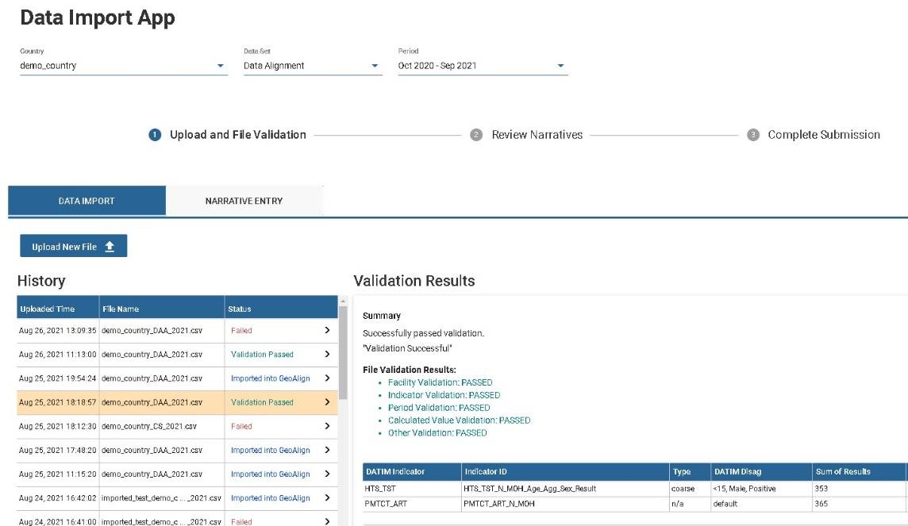
By default, the page provides users with a list of prior uploads including details of the validation results for each file that was uploaded. Additionally, the app automatically loads the current reporting period including the country that was assigned to the user. A progression bar is available to allow you to track where you are in the import process including tabs that you can use to navigate between the data import page and the narrative entry page.

Step 2. Importing Results File for Validation
- Change selected period/ country (if applicable).
Select the period from the dropdown list if you are not importing results for the current period. Also, there may be cases where you are assigned to multiple countries. If that is the case, you will also need to use the country dropdown list to change the country you are importing the results for.
Important: Make sure that the period and the country selected are correct before importing your results file.
- Click on the 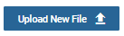 button to access the file upload page.
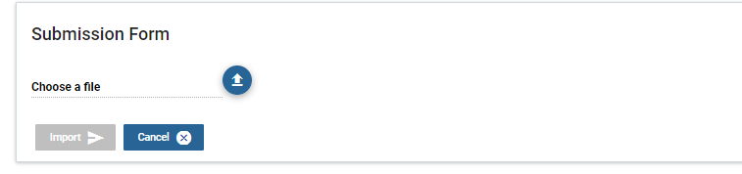
- Click on the button and select the result file that you want to upload.

Important: Only files with the .CSV extension can be uploaded.

- Click to upload a result file to initiate the validation process. If at any time you want to cancel uploading a new result file and return to view a history of uploads, click the button.

Important: It will take 1–2 minutes for the process to complete. Once it is completed, the file will be available for review in the History list. If for any reason you would want to change the file you just uploaded, you will need to click on the button again and upload a new file.

Step 3. Review and Resolve Validation Issues
The validation status of each file upload is in the Status column within the History list. The latest file uploaded will always be the first record in the list.
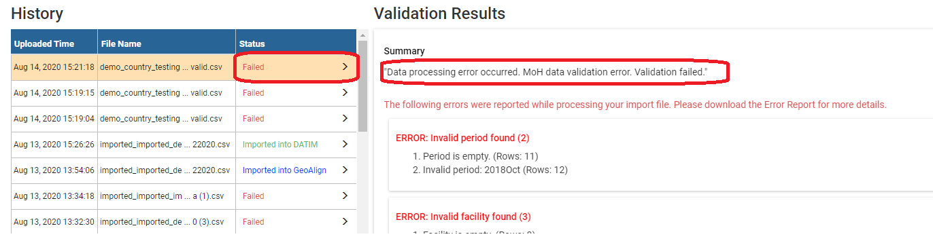
If the validation failed, the reason why will be shown under the Validation Results Summary. Details of the validation errors will also be displayed including how much records have issues. For each failed validation, the type is displayed in red as the header, followed by the detailed information about where the error occurred in the results file.

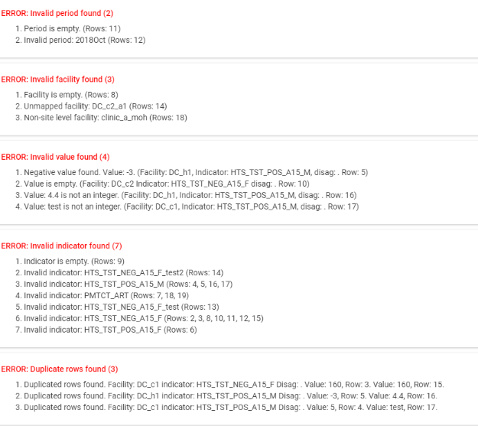

For Central Support a warning sign will show up if there is data that violates the validation rule
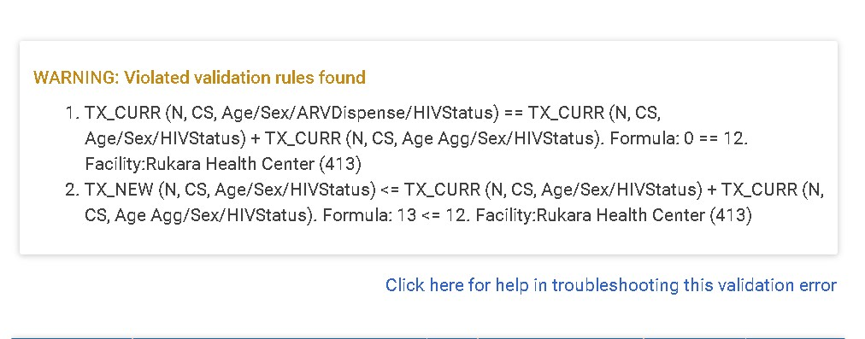
Important: Only a subset of rows with issues will be displayed. You will need to download the Error Report using the button to get the full list of issues. For help with resolving validation issues, use the Click here for help in troubleshooting this validation error link.

Important: You will need to resolve all issues and upload the corrected file before you can move forward to the next step. A sample of the error file is shown below.
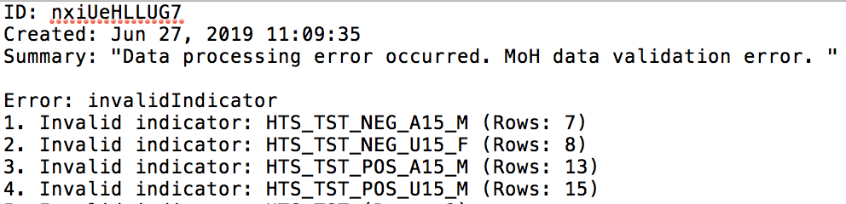

Step 4. Review Import Count
When your file passes validation, the validation results will be shown in green. Review the validation results to ensure the data being displayed is correct before moving on to the next step.

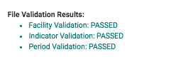
The Import Count and Results Summary tables will also show. Both contains a count of the transformed data in DATIM indicators and disaggregates and includes fields such as DATIM indicator, indicator ID, type, DATIM disag, sum of results, count of the result.
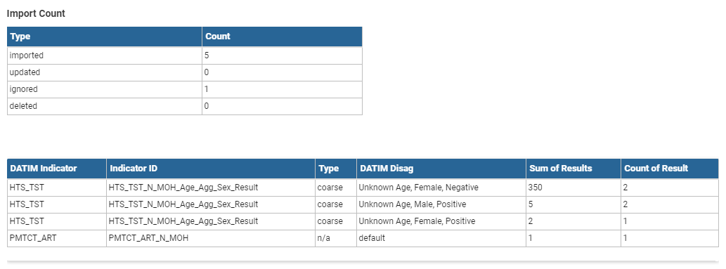

Also, you can perform other actions using the following buttons.
- : - Downloads the imported file you uploaded during the submission process in a CSV format.
- : - Downloads the results summary table in CSV format.
- : - Downloads the indicator mappings used for this submission. The indicator mapping is the one you submitted during the indicator mapping activity

Step 5. Import Data into GeoAlign
After you have reviewed the validation summary you can proceed with importing the data into GeoAlign. Click on the button to start importing the data into GeoAlign. Note, the button will be disabled during the process, which takes 1–2 minutes.
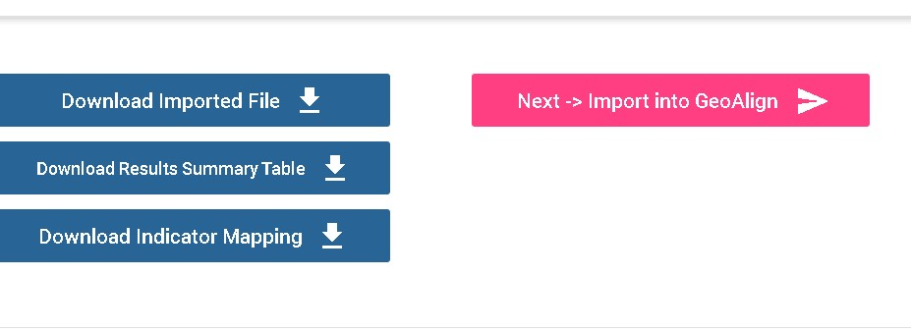

Step 6. View Import Details
After the import process is completed, the status of your import will change from ‘Validation passed’ to ‘Imported into GeoAlign’.
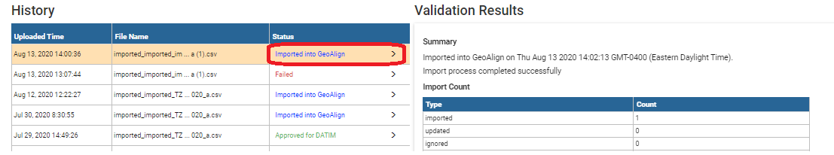
Additionally, the buttons below will also appear

- : - Downloads the transformed site-level data.
- : - Views the imported data displayed in DHIS2 pivot table.

Step 7. Enter Narratives Data
After successfully importing data into GeoAlign, click on the button to go to the Narratives Editor page. Click on the 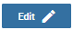 button to add a narrative description for each indicator. Click the button to save the changes you have made.
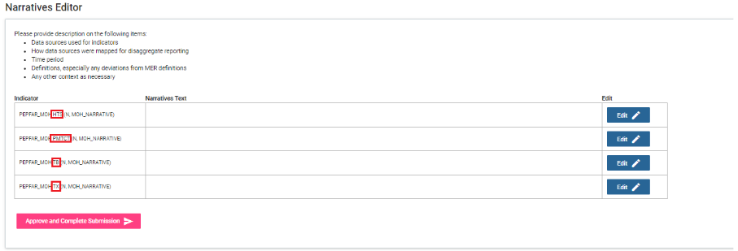

Step 8. Approve Submission for DATIM
When you are done with updating the narrative text, the last step in the click on the button at the bottom of the Narratives Editor page. Once you click the button, the confirmation message below will appear.

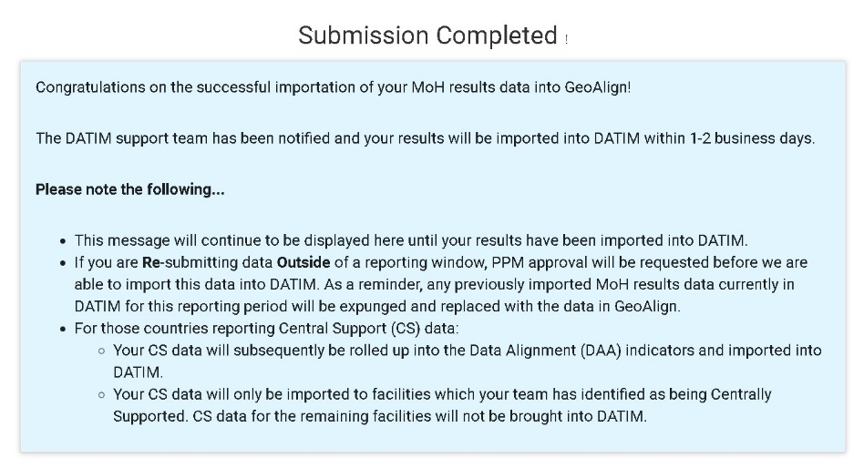
Important: - If you need to make changes at this time, you will not be allowed to. You will need to contact your PEPFAR Program Manager (PPM) to request for the submission to be reverted before you can make changes. Once the PPM has notified you that your submission was reverted, you can process with importing a new data file.

