Data for Accountability, Transparency and Impact Monitoring (DATIM)

Facility Reconciliation App (GOFR) User Guide

August 2020

U.S. Department of State
Office of U.S. Global AIDS Coordinator and Health Diplomacy (S/GAC)

Table of Contents
Steps for Completing Facility Reconciliation 1
Step 1. Access the Facility Reconciliation App 1
Step 2. Upload Facility Reconciliation MoH File 1
Step 3. Map DATIM and MoH Organizational Hierarchies 2
Step 4. View MoH and DATIM Organizational Hierarchies 4
Step 5. Reconcile Facilities 8
I. Flag a Facility for Review 10
II. Save a Match 11
III. Flag as No Match 12
IV. Ignore a Location 13
V. Deleting a Data Source 15
Step 6. Review the Overall Reconciliation Status 16

Facility Reconciliation User Guide
This guide describes the steps to complete the Facility Reconciliation process in the Facility Reconciliation app in GeoAlign. It provides the detailed instructions and explanations needed to perform the facility reconciliation between a country’s list in DATIM with a list provided by the country’s Ministry of Health (MoH). It also provides information to explain concepts and terminologies used in the Facility Reconciliation process.

Steps for Completing Facility Reconciliation

Access the Facility Reconciliation App
- Login to https://GeoAlign.datim.org using your username and password.
- Search for “Facility Recon” app in the search box.
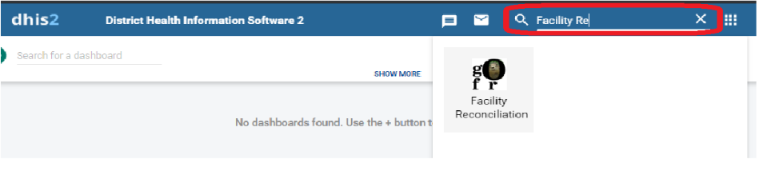
- Click on the “Facility Reconciliation” application icon.

Upload Facility Reconciliation MoH File
- Go to “Data Sources” located on the banner at the top of the screen and select “Add Data Sources.”
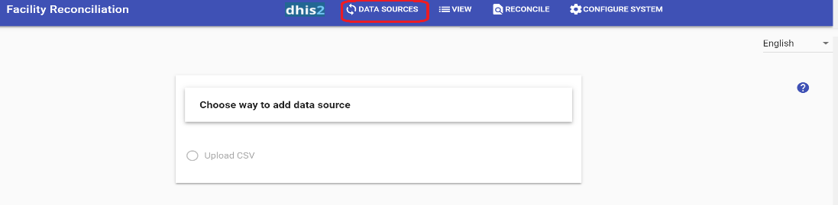
- Click on the “Upload CSV” button to upload the MoH site list in CSV format.
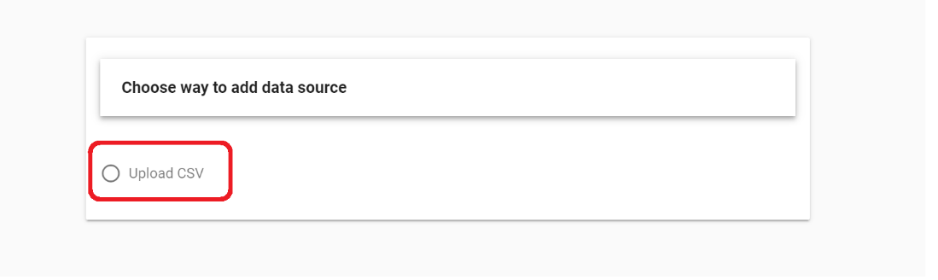
Note: Your CSV file must contain a column with the Facility Name, MoH ID, and at least one hierarchical level for your org unit.
- Enter a unique name for the data file and select the “Choose File” button. You will need to enter a different name each time you upload a file, even if the file has not changed.
Note: When the option “Share with other users of the same org unit as yours” is checked, other users in your org unit will have access to your unique dataset.
Warning: Even though a user in your org unit can access your unique dataset, they will not be able to upload a new dataset.
- Select the MoH site list CSV file from your computer and click on “Open.”
- Click on “Continue” to upload your CSV file.

Map DATIM and MoH Organizational Hierarchies
- Review the Facility Reconciliation app required fields on the right and map them to the column headings in your file.
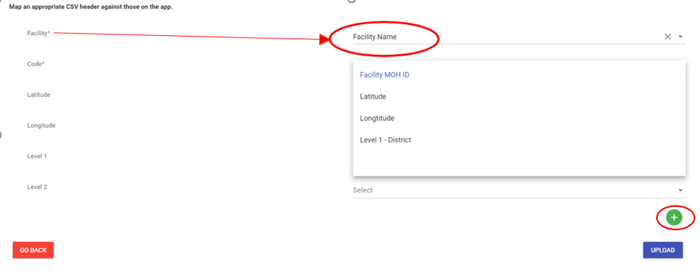
Note: The Facility field should be mapped to the column containing your MoH facility name. The Code field should be mapped to the column containing the Facility MoH ID. Level 1 should be mapped to the highest hierarchy level in the file that corresponds to the DATIM level below country. Level 2 should be mapped to the next highest level after Level 1. To add additional levels, click on the “Add” icon (the green addition button). It is important to note that when mapping levels, you should only map the levels from the MoH file that exist in DATIM. There are certain instances in which a level might exist in MoH but not in DATIM. If that is the case, do not map to that extra level in the Facility Reconciliation app. See the Geopolitical Alignment page for more details about mapping the hierarchies.
- Click on the “Upload” button after completing the header mapping.
- Click on “Proceed” if you are satisfied with the mapping of attributes.
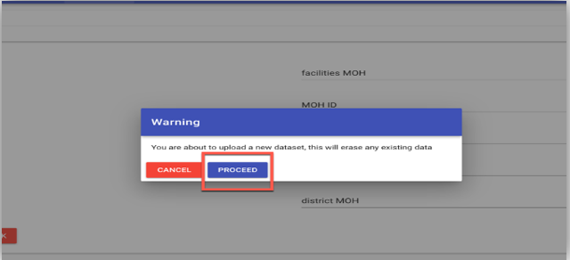
Note: If there are issues in your dataset file, you will see a screen listing one or more of the following issues, which you will need to address before you can successfully upload the dataset.
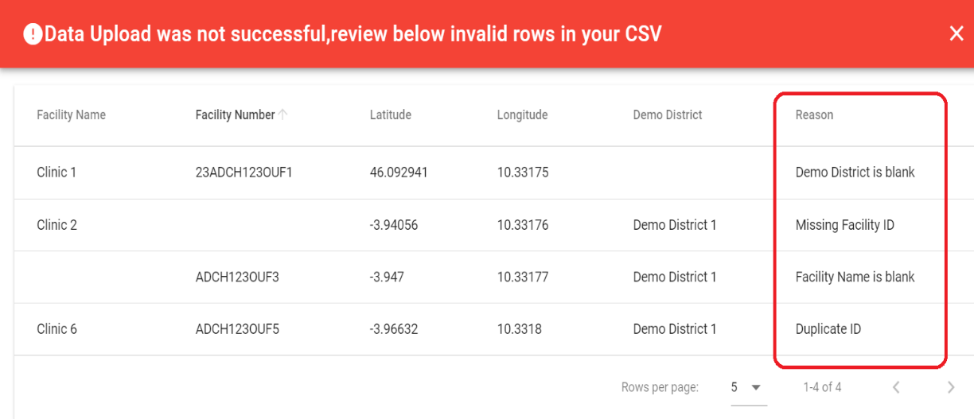
Note: If there are no issues, the file will be successfully uploaded, and a dataset pair will be automatically created between the file you uploaded and the data that have been pulled from DHIS 2 and activated for your org unit. It will then take you to the Reconciliation process. Ensure that the Reconciliation process is happening with the file you just uploaded. The Source 1 name in the top left-hand corner should be the unique name of the dataset file you just uploaded.
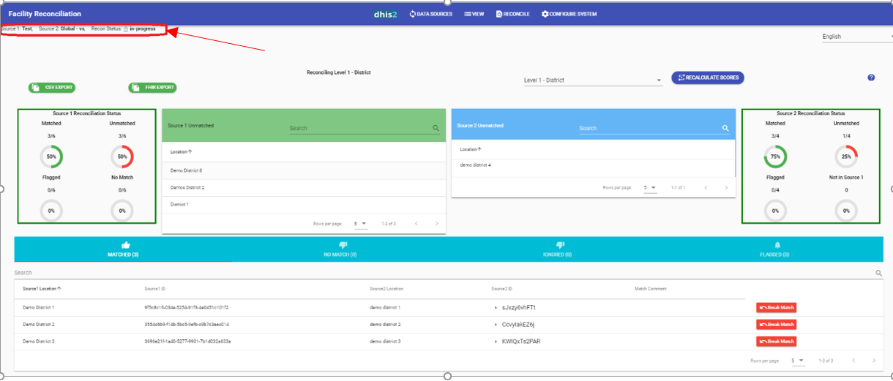
Warning: You can upload only one MoH facility list per user, per org unit. That is, if you are from Demo country, only one user at any given time can upload the master facility list. If you uploaded the incorrect file, you would need to delete the file you have uploaded and re-upload the correct file.
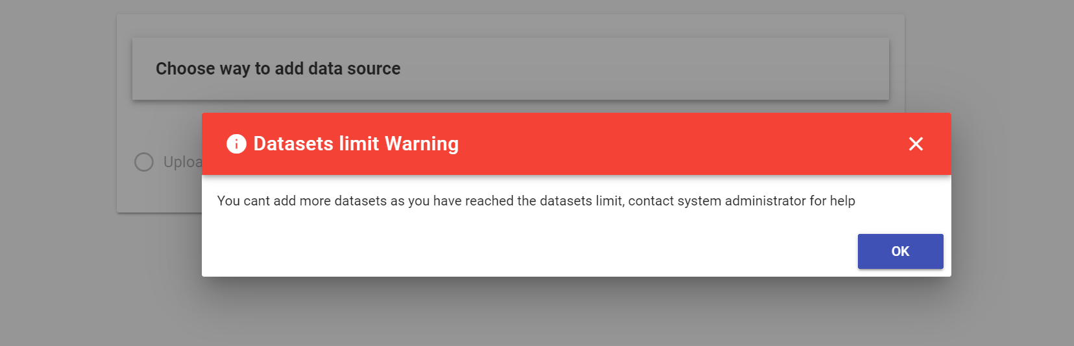

View MoH and DATIM Organizational Hierarchies
- After you are in active Reconciliation, click on the “View” option to review the uploaded MoH Data and DATIM Data trees for comparison.

Note: Source 1 will always contain the MoH facility list that you uploaded, and Source 2 will contain the data from DATIM.
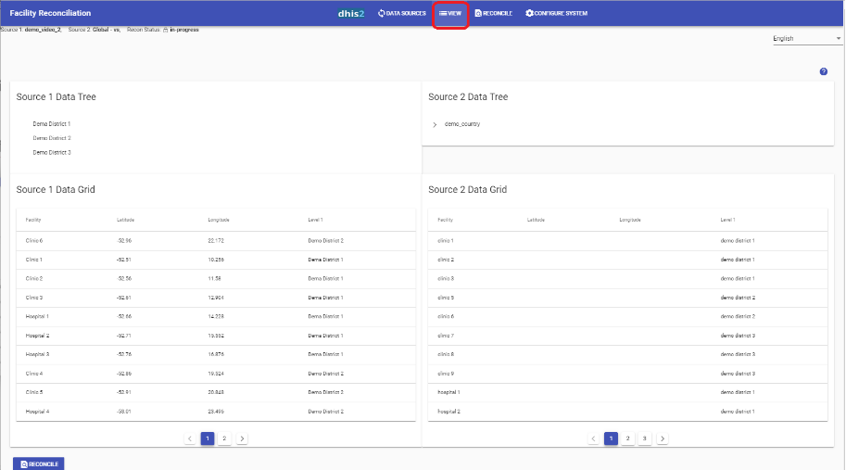
- Click on the Level name or “>” to drill down in the MOH Data or DATIM Data trees.
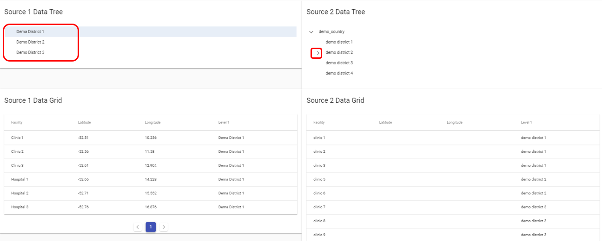
- Note that from the “View” page, the user who uploaded the dataset will be able to make minor changes, such as correcting the spelling of an org unit or changing the parent of a facility. To edit a facility, click on the edit button.
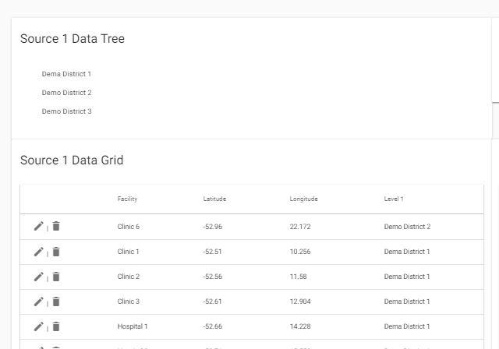
- A screen will appear where you can edit the name or click on the dropdown list to change the parent of the facility.
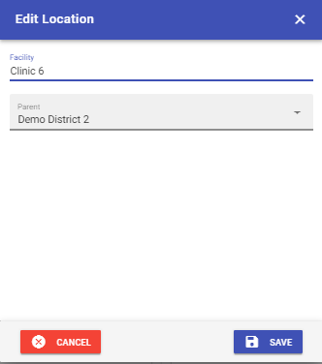

- You can also delete a facility from the list of MoH files to be reconciled if you realize during the process that the facility should not be included or is a duplicate facility.

Warning: Please note, you can only edit facilities in the View tab. To make changes to the higher levels of the hierarchy, you will need to either re-upload the file with changes OR make the changes in the org unit hierarchy in GeoAlign. When you are working in the Facility Reconciliation app, your site admin privileges in DATIM are disabled. However, you can make edits in the hierarchy in GeoAlign through the Maintenance app. Note, GeoAlign is synced with the Facility Reconciliation app every 15 minutes, so if you make an update, the changes will appear in the Facility Reconciliation app after the sync is completed.

Reconcile Facilities
- To return to the Reconciliation process, click on the “Reconcile” button on the View page or go to Reconcile located on the banner and then select the option “Reconcile.”
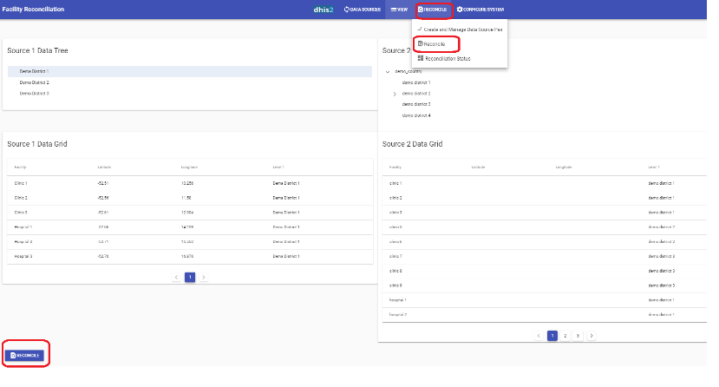
- Review the Reconciliation page for the list of records that were auto matched and unmatched.
Note: The Facility Reconciliation App auto matches by the MOH ID. It also matches facilities or levels with the same name and the same parent. After completing the file upload process, the app searches your MoH master list and compares it with the dataset from DATIM. If a corresponding record is found, it will be automatically matched and added to the “Matched” list.
If a record does not automatically match, it will show up in the Source 1 “Unmatched” list. You will then need to click on each record in this list and decide if it should be flagged, if one of the suggested matches should be saved, if it should be flagged as no match, or if you should ignore it.
Warning: You will need to reconcile each level before completing the Reconciliation process. The tool will walk you through the mapping process level by level.
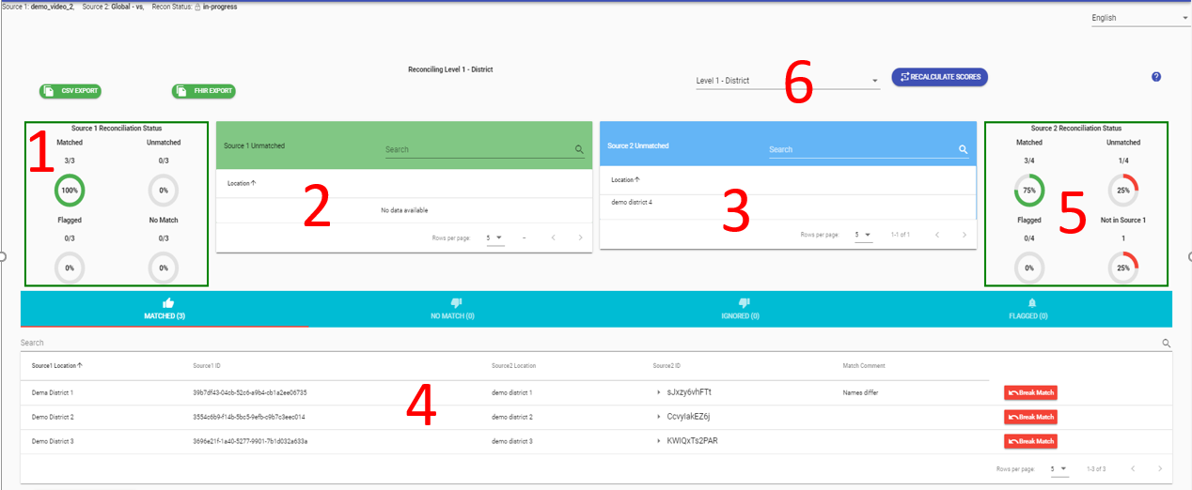
Table 1: Description of the Reconciliation Page
Item # | Description
1 | Statistics on Source 1 Reconciliation Status
2 | Shows a list of all of Source 1 unmatched levels and facilities
3 | Shows a list of all of Source 2 unmatched levels and facilities
4 | Shows a list of levels and facilities that were matched, flagged, ignored, or had no matches
5 | Statistics on Source 2 Reconciliation Status
6 | Dropdown list of each level
Click on the first record in the Source 1 “Unmatched” list. You will be taken to the manual match screen. The figure below shows parts of the match screen, and Table 2 provides a description of each action that can be taken from the manual match screen.
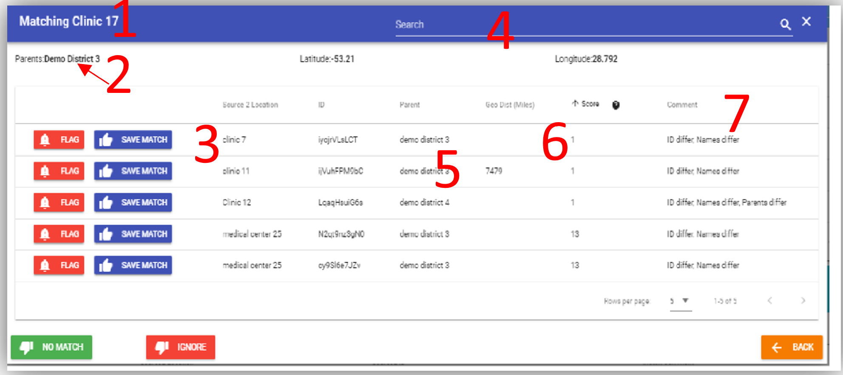
  - 1 = Refers to the name of the location being matched
  - 2 = Refers to the parent of the location
  - 3 = List of possible matches
  - 4 = Search feature for levels or facilities
  - 5 = List of parents of possible matches
  - 6 = Refers to the match probability, or the likelihood that the two locations are a match
  - 7 = Gives the user details about the potential matches, such as whether the parents are different. The ID will always differ in manual matches because:
    - The DATIM site does not have an MoH ID yet and therefore is blank.
    - The DATIM site already has an MoH ID, and it does not match the MoH ID of the MoH facility being matched.
Table 2: Actions for Manual Mapping
Action | Description
 | Pairs the MoH unit with the DATIM unit. If it is a facility, it will add the MoH ID to the DATIM facility as an attribute.
For above facility org units | No match means that there is not a corresponding location in DATIM. You cannot have “no match” for above facility org units. If there is a location in the MoH hierarchy that is not in DATIM, you will need to first go back and revise the levels in the DATIM hierarchy using the OrgUnit app in GeoAlign so that they match the MoH levels. The Geopolitical Alignment support page has more details on this process.  Note: GeoAlign is synced with the Facility Reconciliation app every 15 minutes, so if you make an update, the changes will appear in the Facility Reconciliation app after the sync is completed.  After you have revised the hierarchy in GeoAlign, you will need to restart the Reconciliation process by deleting your previous MoH dataset and uploading it again using a different name. See the section on “Deleting data sources” for instructions on how to delete a data source so you can re-upload a revised file.
For facilities | When you mark a facility as having “no match,” this will mean that a new facility will be created in DATIM that corresponds to that MoH facility name and ID.
 | Ignored locations or facilities will not be included in the Reconciliation process.
 | When you flag a record, you are marking it to be reviewed later. All flags must be cleared to move to reconciling the next level.
 | This will return you to the Reconciliation page.
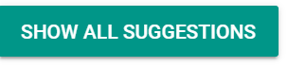 | This shows all the unmatched locations from Source 2, not just the scored suggestions.

- Review the list of records and select the appropriate action for the location.
Note: After you have selected an option, you will return to the Reconciliation page.
- Additional instructions for using the actions found in the Reconciliation page are provided below.

Flag a Facility for Review
- From the list of potential matches, click on the “Flag” button beside the record you would like to flag for review later.
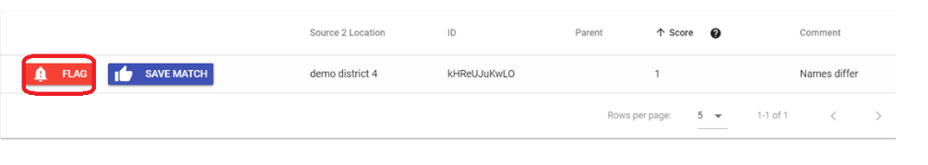
- Enter a comment and click on the “Continue” button.
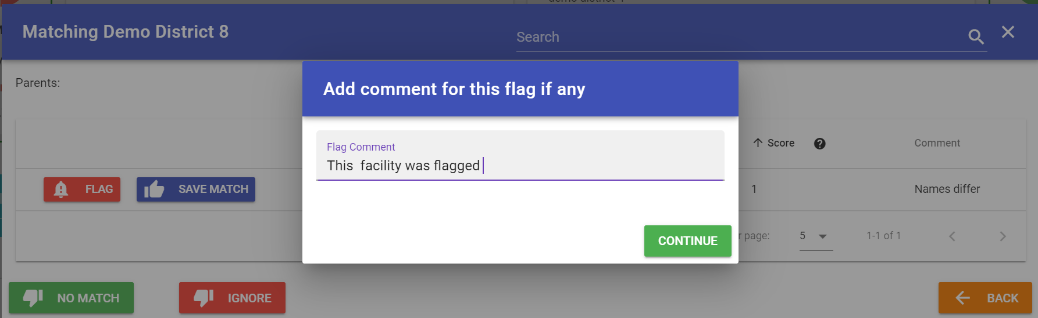
- The record will then be added to “Flagged” list. You can review the records flagged anytime by clicking on the “Flagged” list.
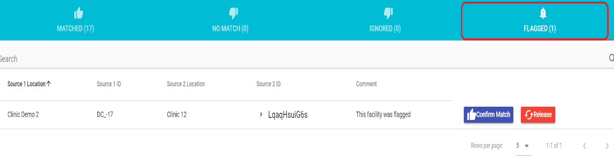
Warning: You will not be able to proceed to the next level if there are records in the
“Flagged” list. You must either confirm the match or release the record. If the record is released, it will go back to the Source 1 “Unmatched” list, where you will need to take further action. If you click on “Confirm Match,” the records will be matched and the “Matched” list will be updated.
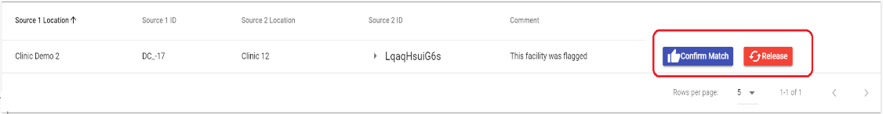

Save a Match
- From the list of potential matches, click on the “Save Match” button beside the record you think best matches the location.
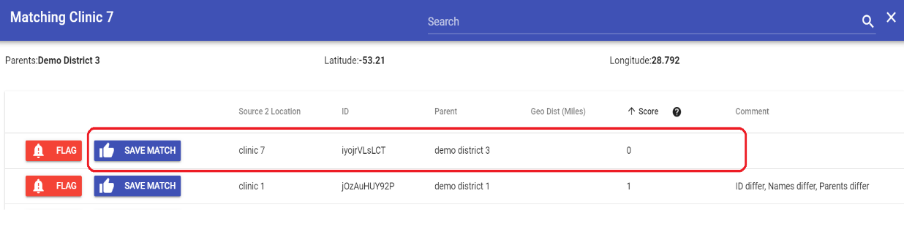
Note: The Score is the match probability, or the likelihood that the two locations are a match. This score is calculated based on an algorithm in the tool. The lower the score, the higher the likelihood of a match. Click on the “Show All Suggestions” button to see all the unmatched locations from Source 2, not just the scored suggestions.
- The record will then be added to the “Matched” list. You can review the matched records anytime by clicking on the “Matched” list.

Note: In the “Matched” list, you can view the matches made and any comments about the matches. If at any time you find something that was matched that should not be matched, you can click on the “Break Match” button to unlink the locations. You will be notified that the scores for this location may not be available unless you recalculate the scores. Click on “okay” and then click on the “Recalculate Score” button. The record will be moved into the Source 1 “Unmatched” list.
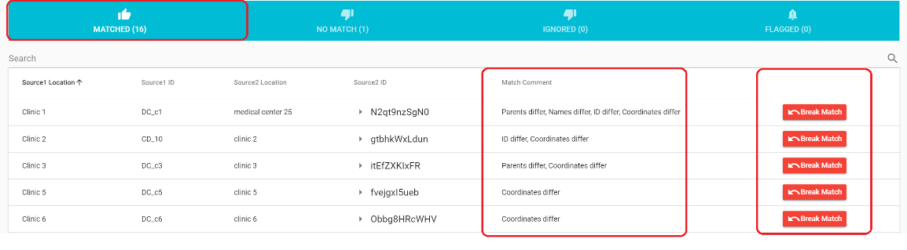
Warning: If you break a match, it will go back to Source 1 “Unmatched” list, and you will need to take further action before you can more to the next level. You may also need to recalculate the scores.
- From the “Matched” list, you can also view the IDs of the matched facilities. In the Source 2 ID column, you will see a list of IDs for each facility. If you click on the triangle next to the ID, other IDs associated with that facility in DATIM will appear. If the Match Comment is “IDs differ,” you can check to see whether this is because the DATIM facility does not have an MoH ID or the MoH ID the facility has is different. Facilities in DATIM should have only one MoH ID. Matches should not have two different MoH IDs.
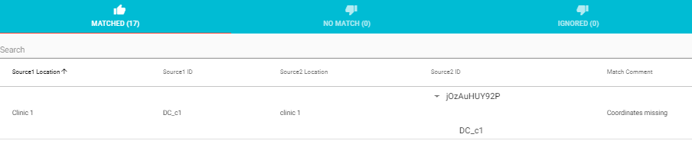

Flag as No Match
- From the list of potential matches, click on the “No Match” button for the location for which you could not find a match.
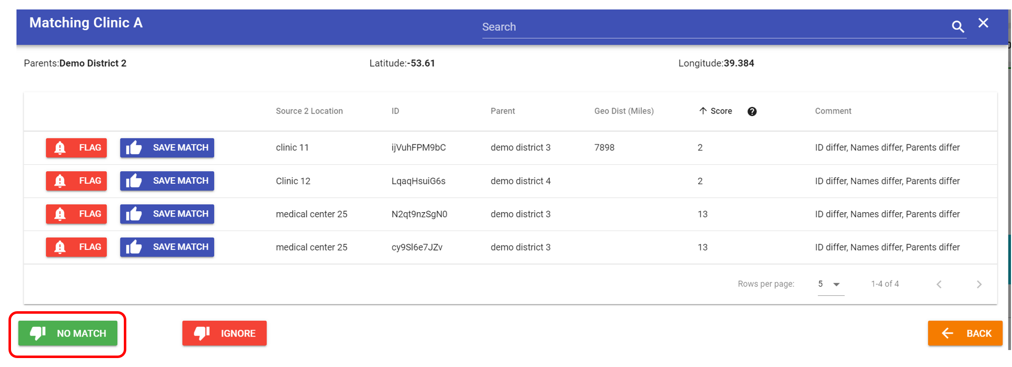
Note: You cannot have “No match” in the levels above facilities. If there is a location in the MoH hierarchy that is not in DATIM, you will need to first go back and revise the levels in the DATIM hierarchy in GeoAlign so that they match the MoH levels. The Geopolitical Alignment support page has more details on this process. After you have revised the hierarchy in DATIM, you will need to restart the Reconciliation process by deleting your previous MoH dataset and uploading it again using a different name.
- The record will then be added to the “Unmatched” list. You can review the records that have no matches anytime by clicking on the “Unmatched” list.
Note: If you need to break the “no match” at any time, click on the “Break No Match” button.
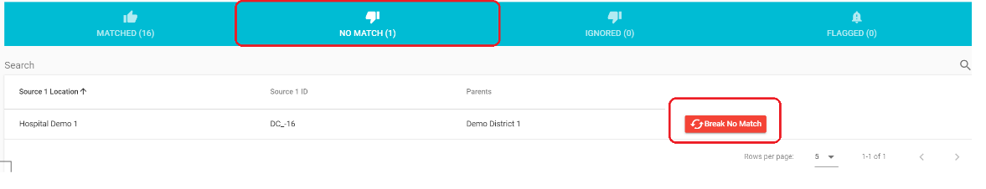
Warning: If you break a “no match,” it will go back to Source 1 “Unmatched” list, and you will need to take further action before you can more to the next level. You may also need to recalculate the scores.

Ignore a Location
  - From the list of potential matches, click on the “Ignore” button for the location that you do not want to be included in the Reconciliation process.
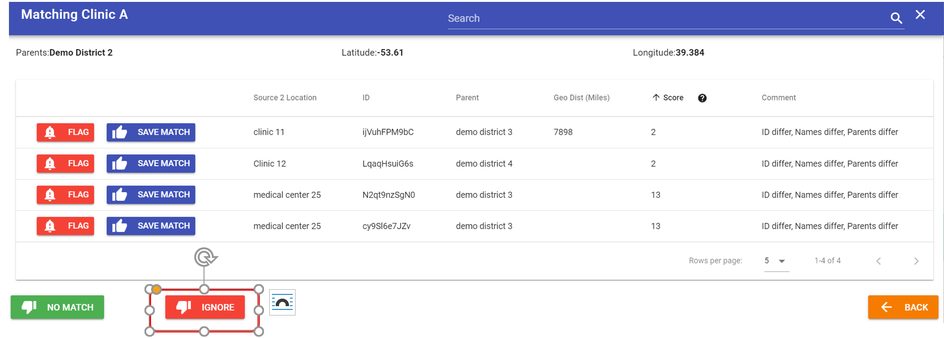
  - The record will then be added to the “Ignore” list. You can review the records that were ignored anytime by clicking on the “Ignore” list.
Note: If you need to break records that were ignored at any time, click on the “Break Ignore” button.
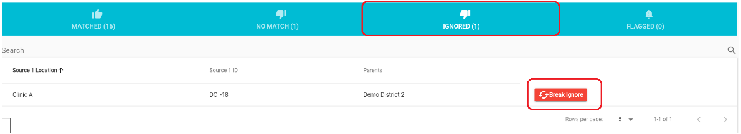
Warning: If you break an ignored facility, it will go back to Source 1 “Unmatched” list, and you will need to take further action before you can more to the next level. You may also need to recalculate the scores.
- Review your lists of matches, no matches, ignored, and flagged locations to ensure that all locations are in the correct group.
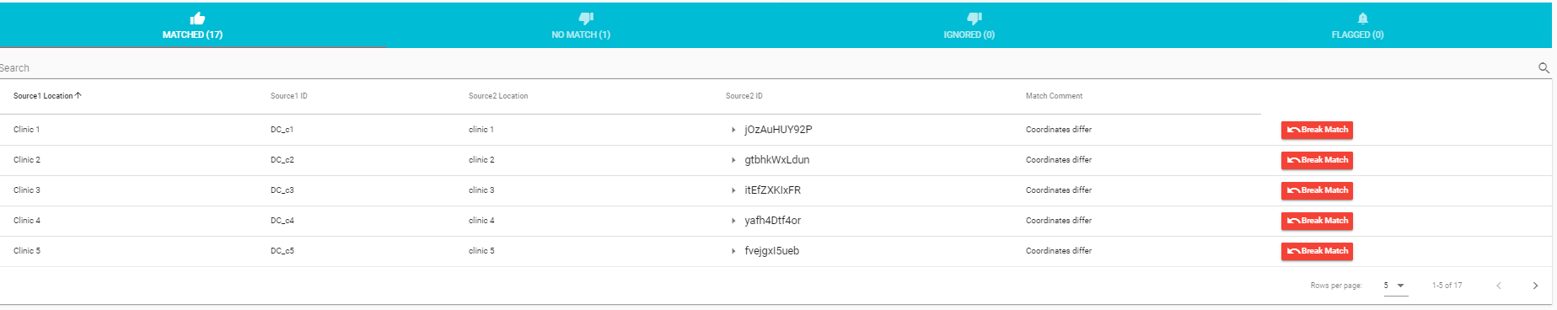
- Once you have cleared out the unmatched locations from Source 1 “Unmatched” list, a button will appear at the bottom of the screen for you to proceed to the next level.
Warning: The button will not appear until the Source 1 “Unmatched” list is cleared.
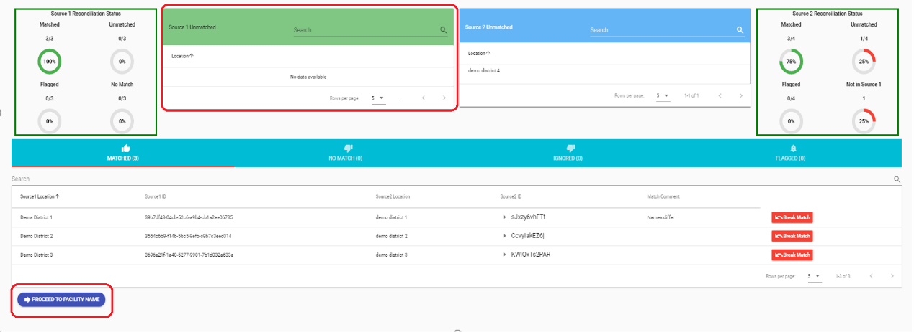
Note: It is okay if there are unmatched locations of facilities in the DATIM hierarchy (Source 2).
- Repeat the above steps until the “Reconciliation Status” button appears.
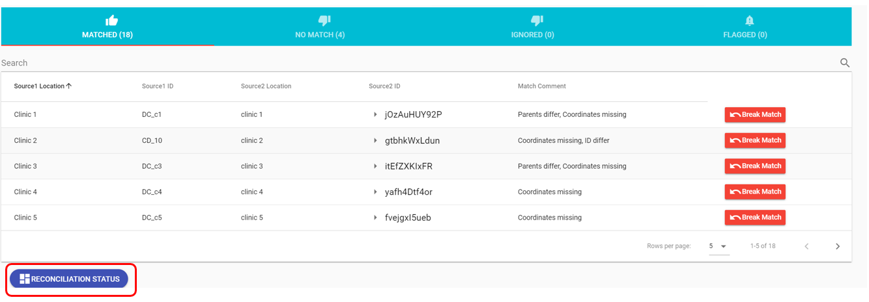
- Click on the “Reconciliation Status” button to review the overall Reconciliation process status.

Deleting a Data Source

If you need to make changes to the MoH facility list you have uploaded that cannot be made in the “View” page, you will need to first delete the data source.
- To delete a data source, click on “Data sources” and select “View data sources.”

- In the view data sources screen, there is a table called “Uploaded Sources.” In that table, you will see the file you uploaded. Select the file and then click on “Delete.”

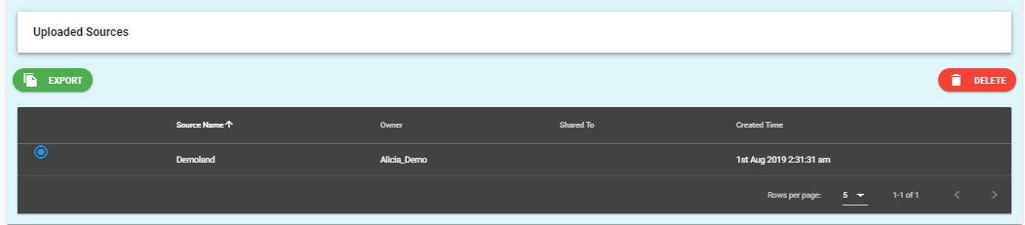

- When you click on “Delete,” a warning will appear letting you know that the pair that was created with the data source will also be deleted. Click on “Yes” to continue with deleting the data source.

Note: Only the user who uploaded the data source will be able to delete the data source.
Warning: All matching data that were completed in the pair will be deleted when the data source is deleted.
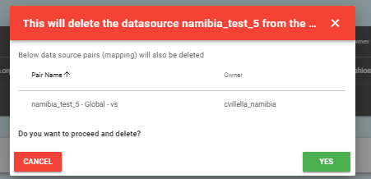

Review the Overall Reconciliation Status
      - Review the statistics of the overall Reconciliation process. On the left, the dashboard provides a final count of all records for each group per source.

Note: The count for Source 1 and 2 Flagged will always be zero. This is because you must remove all flags before proceeding to the next level.
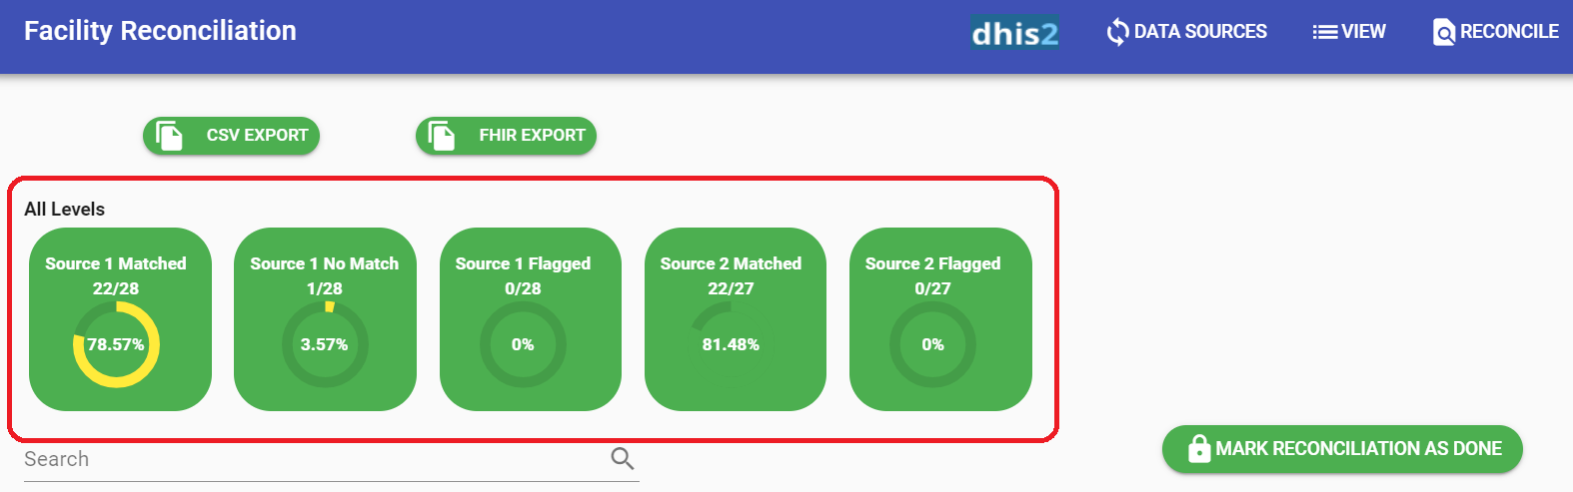
      - Review the statistics per level by changing the level and reviewing the count. To verify the current level being reviewed, look at the top left-hand corner.
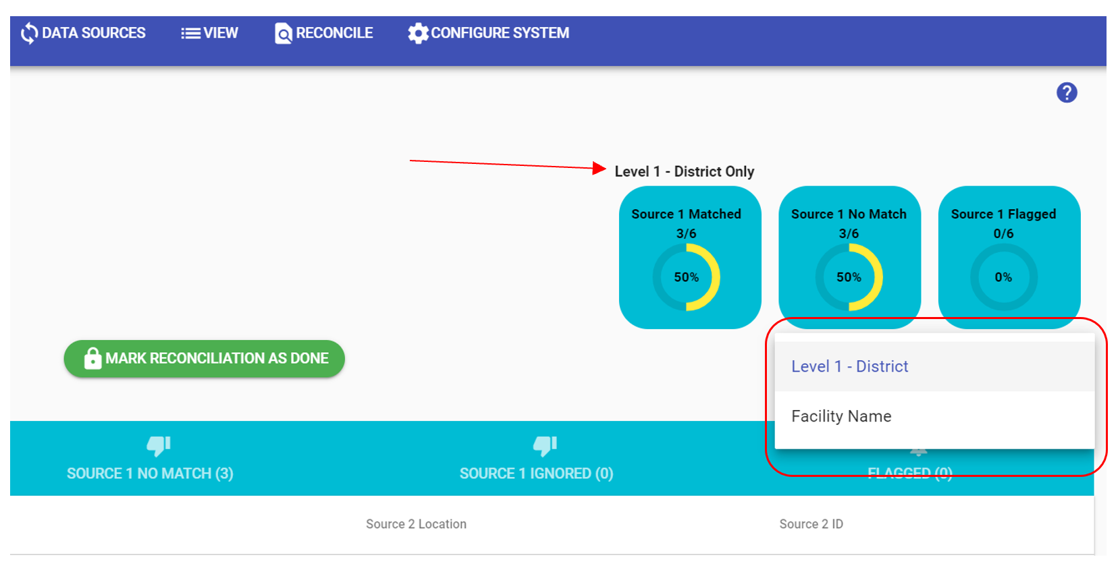
      - You can also review the complete list per group by clicking on the lists of matches, no matches, ignored, and flagged locations.
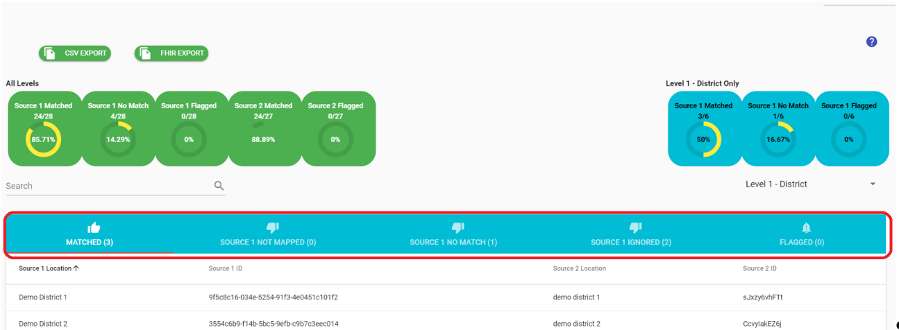
      - If you are satisfied with the list of facilities that were reconciled, click on the “Mark Reconciliation as Done” button.
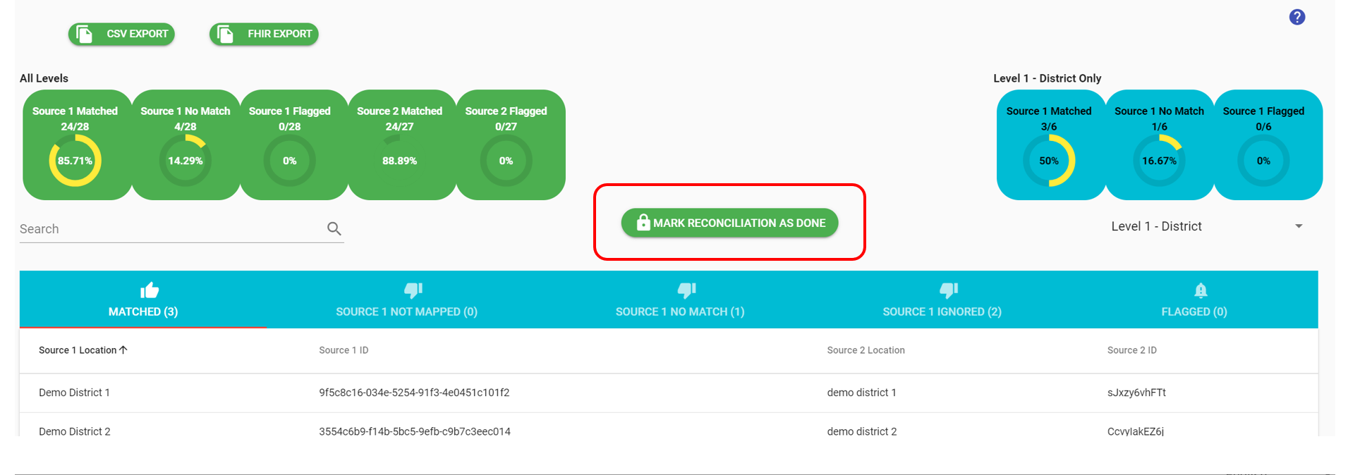
Warning: If you mark the Reconciliation process as done, you will not be able to make any changes to the data.
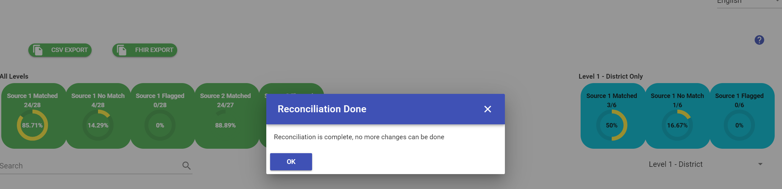
      - After you have locked the Reconciliation process, you can export and review the Reconciliation Status Report by exporting it in either a CSV or FHIR format. Select an option from the list to download the file.
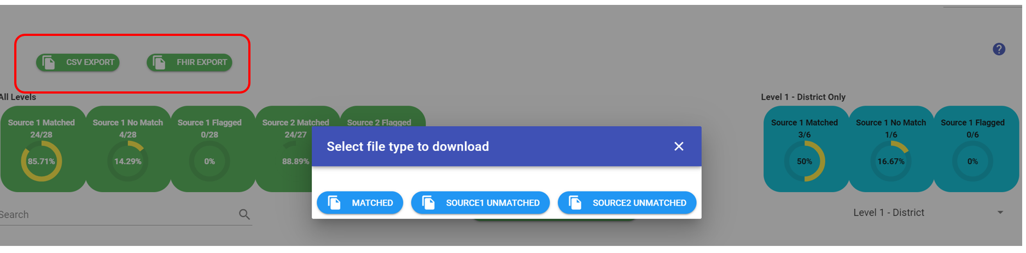
      - Submit a request to DATIM Support confirming that you have completed your Facility Reconciliation and are now ready for the data to be added to DATIM.
Note: If you need to make an edit to your Reconciliation after you have marked it as done, please contact the DATIM support team, and someone from the support team will be able to unlock the Reconciliation so that you can make edits to it.

Please reach out to your DATIM Support if you encounter any issues or if you have questions.

