Data for Accountability, Transparency and Impact Monitoring (DATIM)

SIMS 4.2 Data Import Reference Guide

January 2023

U.S. Department of State
Office of U.S. Global AIDS Coordinator and Health Diplomacy (S/GAC)

Revision Table
Version | Date | Revision Details
1.0 | January 2023 | See section titled “What’s New”

Table of Contents
1 Document Scope 1
2 What’s New 1
2.1 Changes to SIMS Metadata 1
2.2 Changes to This Reference Guide 1
3 SIMS Data Import Approach 1
4 Roles and Responsibilities 1
5 PEPFAR Reporting Timelines and SIMS Data Import Eligibility Rules 1
6 Characteristics of DATIM Data 2
7 Construct Appropriately Formatted Files for Import 2
7.1 SIMS Data Elements 2
7.1.1 Valid Data Types 3
7.2 Value 4
7.3 Period 4
7.4 Comment Field 4
7.5 Organization Units 4
7.5.1 Reporting Levels 4
7.6 Attribute Option Combo 5
8 Example CSV files 6
8.1 CSV Naming Convention 7
9 Data Import Testing 7
9.1 Validation Scripts 8
9.2 Agency DEV-DE Testing Credentials 8
10 Submit the SIMS Data File for Import into DATIM 8
10.1 Communicate Data Import File and Test Results to the DATIM Support Team 9
10.2 SIMS Data Import into DATIM (Performed Exclusively by the DATIM Support Team) 10
11 DATIM’s Policy and Process for Managing Organizational Hierarchy Changes 10
11.1 Deleting Sites 11
11.2 Relocating or Merging sites 11
11.3 Communicating Organizational Hierarchy Changes to Agency Stakeholders 12
12 Resources 12

1 Document Scope
This Data for Accountability, Transparency and Impact Monitoring (DATIM) Data Import Reference Guide serves as a resource outlining the steps involved with importing Site Improvement Through Monitoring System (SIMS) version 4.2 data into DATIM. Data intended for import into DATIM must satisfy strict requirements with respect to the format of the data as well the relationship of the data to the current metadata of the system. Data must be valid with respect to the destination sites, data elements, and mechanisms.

2 What’s New

2.1 Changes to SIMS Metadata
SIMS 4.2 introduces the following changes to the above-site and site-based CEEs.
- Only site-based CEEs will be involved in data collection. No above-site data will be reported.
- Agencies will submit data to DATIM as usual. However, the Data Import team will filter out CEEs that are not Infection Prevention and Control (IPC). Only 8 CEEs and their corresponding cover sheet data will be retained for import and for the IPC Dossier and all data not pertaining to the IPC will be filtered out prior to DATIM import.
CEE ID | CEE TITLE | CEE SHORT TITLE
S_01_06 | TB Infection Control
S_01_07 | Waste Management
S_01_08 | Injection Safety
S_10_02 | Lab Biosafety [LAB]
S_01_28 | Infection and Prevention Control Program
S_01_29 | Environmental Cleaning Procedures
S_01_30 | Availability of Personal Protective Equipment
S_01_31 | Decontamination and Reprocessing of Medical Devices

2.2 Changes to This Reference Guide
The following are the major updates in this version of the document:
- Removed references to above-site since only site-based data will be reported in SIMS 4.2
- List of points of contact, Section 4

3 SIMS Data Import Approach
Agencies do not have the ability to directly import their SIMS data into DATIM. Instead, the DATIM Support Team has developed an import process to facilitate the import of SIMS data into DATIM. This data import is the process of importing appropriately formatted files into DATIM using the Import-Export application; only the DATIM Support Team has access to this app in DATIM.
This document outlines this process, which involves the following: (1) each agency’s technical representative testing their SIMS import files in Dev-DE.datim.org (a DATIM test environment) and using R Script validations to ensure that their files are compliant with DATIM import requirements and specifications as explained in this document, and (2) submitting a valid file and working with the DATIM Support Team to successfully import the file into the production DATIM environment. A summary of this process is outlined in the illustration that follows. This document provides details for each of the steps in the process.

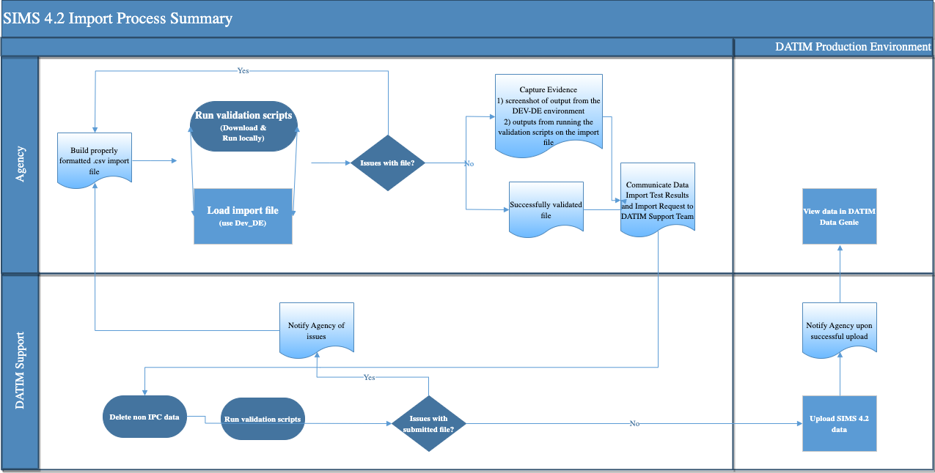

4 Roles and Responsibilities
Stakeholders | Roles and Responsibilities
DATIM Support Team | The DATIM Support Team has developed a validation script to perform system validation on SIMS 4.2 data. Upon receiving a file for import, the DATIM Support Team will run the validation scripts on the import files prior to attempting any import. If any issues are detected, the file will not be imported, and the participating agency will be notified of validation findings for the purpose of correction, revalidation, retesting, and resubmission of an updated file to the DATIM Support Team. The team is also responsible for filtering out any assessments that do not include IPC data since those assessments will not be imported into DATIM.  The DATIM Support Team is responsible for providing instructions on how to access and execute the validation scripts.  The DATIM Support Team is available to provide assistance throughout this process. Stakeholders may contact the DATIM Support Team via the DATIM Support app in DATIM.
SIMS Implementing Agency Technical Representatives | Designated representatives from each agency are responsible for submitting the request, accompanied by evidence of successful SIMS 4.2 data import in Dev-DE, to the DATIM Support Team for SIMS 4.2 file import into DATIM.  Prior to that submission, these representatives are responsible for coordinating and managing their teams through the process of creating a properly formatted CSV import file, running the import file through the validation script, testing the import using Dev-DE.datim.org, and capturing results of the validation and test import.  Implementing agency technical representatives may engage other agency personnel in support of this import testing process, but an import request will be accepted by the DATIM Support Team only if it comes from a designated implementing agency technical representative. A listing of these representatives follows. Requests for access to the Dev-DE.datim.org site should be delivered to the DATIM Support Team.
 |  | Agency | Name | Email Address
 |  | CDC | Roma Bhatkoti | nli0@cdc.gov
 |  | CDC | Yakubu Owolabi | juu6@cdc.gov
 |  | DOD | Danielle Connor | danielle.r.connor2.ctr@mail.mil
 |  | DOD | Ayesha Rashid | ayrashid@hivresearch.org
 |  | HRSA | Salem Gugsa | sgugsa@hrsa.gov
 |  | HRSA | Laura Foradori | LForadori@hrsa.gov
 |  | USAID | Roney Akter | rakter@usaid.gov
 |  | USAID | Jacob H. Buehler | jbuehler@usaid.gov

5 PEPFAR Reporting Timelines and SIMS Data Import Eligibility Rules
All data (including SIMS data) should be reported to DATIM in accordance with the timeline specified in the PEPFAR data calendar. In accordance with the PEPFAR data calendar, only SIMS 4.2 data for the current data reporting quarter will be accepted for import into DATIM. For example, this means that during the FY23 Q1 reporting period, only SIMS 4.2 data for FY23 Q1 can be submitted.
Note: Back entry of data from previous quarters is no longer accepted. Only data from the current/applicable period will be imported into DATIM.

6 Characteristics of DATIM Data
Data values in DATIM are always associated with four dimensions, which describe different aspects of the data:
- Where—Organization unit: This dimension describes the location of the data.
- What—Data element: This dimension describes the phenomena to which the data value is attached.
- When—Period: This dimension describes the time period of the data being reported.
- Who—Funding mechanism: Also known as the “attribute option combination,” this is an extra custom dimension in DATIM that describes the implementing mechanism for which the data are being reported.
All data in DATIM contain these four dimensions, also known as metadata.

7 Construct Appropriately Formatted Files for Import
A correctly formatted CSV file containing SIMS data should be generated. Only the following columns are required in the CSV file (order is important):
Dataelement | Period | OrgUnit | CategoryOptionCombo | AttributeOptionCombo | Value

The header in the CSV file is optional. When importing the file, after selecting the CSV format of the file, you are given an option to specify whether the first row is a header. If your file has a header, but you leave the default option “No” selected, the system will behave as it did previously, and the summary will include a warning that can be ignored: “data element cannot be found or not accessible.” During the import, select the option corresponding to your file. If the file does not have a header, make sure to select “No,” because otherwise the first row will be ignored.
Note: For SIMS data, the category option combo should be included; however, the value must always be the default. The code and unique identifier (UID) for the default value are the same and should be “HllvX50cXC0.”

7.1 SIMS Data Elements
SIMS data in DATIM must have a data element and disaggregation (also known as a category option combination).
Data element and category option combos/disaggregations can be reported as either code or a UID.
Please refer to the code list on the DATIM Support page (https://datim.zendesk.com/hc/en-us/articles/115002334246-DATIM-Data-Import and-Exchange-Resources) for the appropriate data element names, codes, and UIDs.
Use the data element name (which matches SIMS 4.2 data dictionary data element identifiers) or UID to identify them in the import file.
As mentioned above for SIMS data, the category option combo should include and must always be the default value. The default value is HllvX50cXC0.
There are two types of SIMS 4.2 code lists: (1) Site-Based Data Elements and (2) SIMS v4 Option Sets.
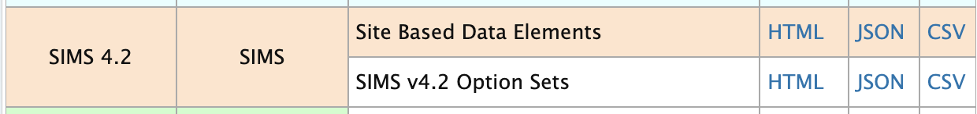

7.1.1 Valid Data Types
SIMS data elements are modeled based on the SIMS data dictionary data element types.
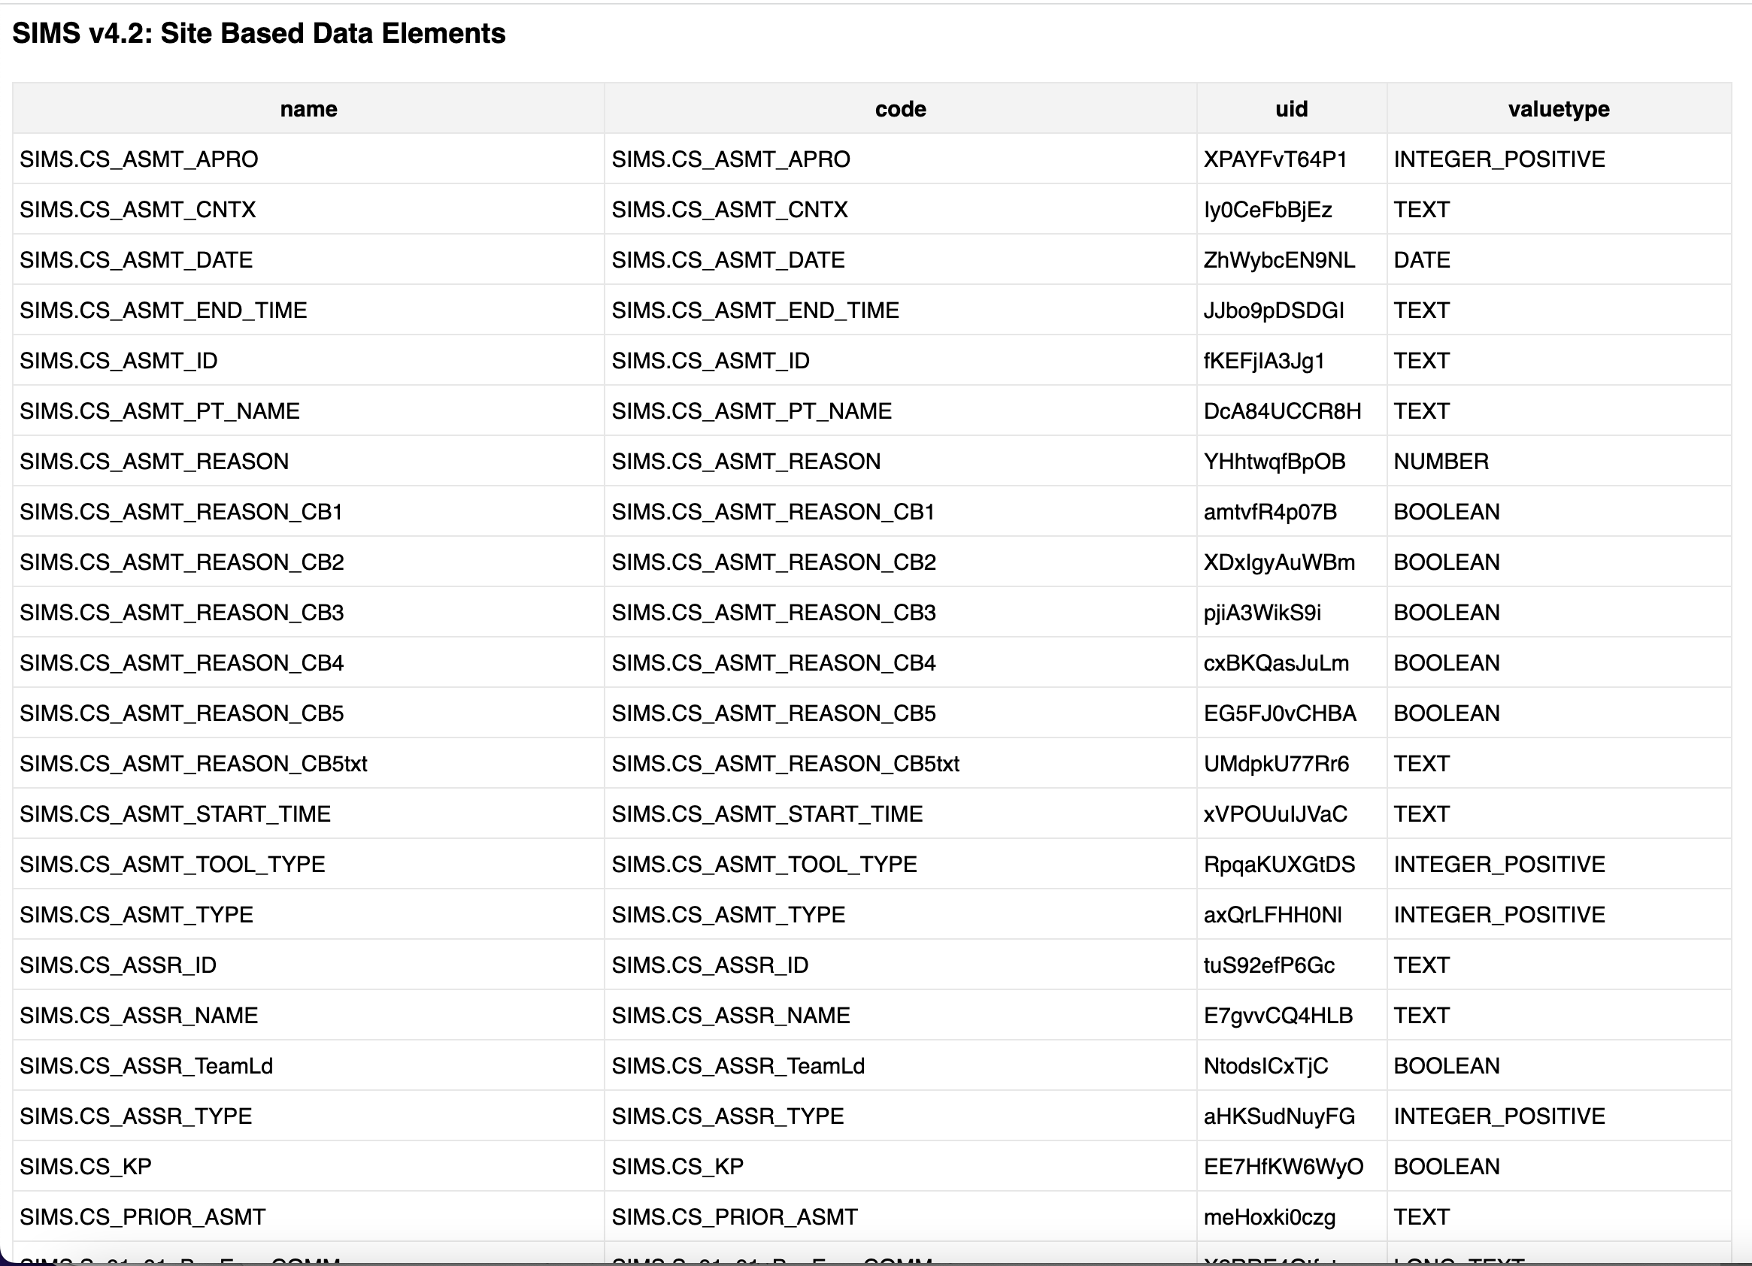
SIMS data element names follow a naming convention to allow consistency and easy identification of the associated valid value types. The naming convention is as follows.
Field Name | Data Type | Valid Values/Format/Special Considerations
*_COMM | string | 50k character text
*_SCORE | integer | zeroPositiveInt
*_RESP | bool | true/false (all lowercase)
*_CB* | bool | true/false (all lowercase)
*_PERC | integer | zeroPositiveInt
*_NA | bool | true/false (all lowercase)
*_Date | date | YYYY-MM-DD (2023-01-01 for January 01, 2023)  Note: This is different from the period date format.
*_Agency | string | 50k character text
*NUM | integer | zeroPositiveInt
_DEN | integer | zeroPositiveInt
*_TXT | string | 50k character text
*_TIME | string | 50k character text
_KP | bool | true/false (all lowercase)
_TYPE | integer | zeroPositiveInt

7.2 Value
The value field is constrained to acceptable value type as determined by the associated data element as outlined above. Refer to the table above to determine the valid format based for the associated data element’s naming convention.

7.3 Period
Each data value in DATIM must have a valid period. SIMS data are currently reported on a daily basis; hence the period should be reported using yyyyMMdd format using calendar year: for example, 20230101 for January 01, 2023, 20230102 for January 02, 2023.

7.4 Comment Field
The comment field is also required and will be used to provide information (such as the agency system’s unique assessment ID) to identify and differentiate the visits (i.e., to determine which group of data elements belong with which visit). It is fundamental that each “visit” is clearly grouped with a comment.

7.5 Organization Units
Organization unit is typically the site where the data are captured. Examples are site, facility, community, district, and county. This should not be confused with PEPFAR Operating Unit. Facility, site, community, and OperatingUnit codes and UIDs are available in the current code list available on the DATIM Support page (https://datim.zendesk.com/hc/en-us/articles/115002334246-DATIM-Data-Import-and-Exchange-Resources).
Use of the code field of the organization unit metadata in DATIM is not required. Many sites lack the code attribute, and as such UID should be used when reporting the data.
Note: To access these codes, users must be logged into DATIM Support because this is a password-protected resource.

7.5.1 Reporting Levels
Unlike previous versions that allowed SIMS data reporting at two organization hierarchy levels (site and above-site) SIMS 4.2 version allows site level data only which is data for assessments associated with community and facility levels.

7.6 Attribute Option Combo
Attribute option combo refers to the funding mechanism for which the data apply. An example is “25147,” which refers to the FACTS Info mechanism ID. FACTS Info is the source for the DATIM implementing mechanisms. Data from FACTS Info are regularly synchronized with DATIM. All mechanisms that are present in a given data import file must be active for the period for which data are being imported. After a mechanism is “promoted” or made active in FACTS Info, it will take up to 24 hours for the data to be updated in DATIM. Please ensure that all mechanisms for which you will be reporting data are active in FACTS Info prior to attempting to test any data in the DEV-DE test environment. If any mechanisms are not active, or data need to be reported against mechanisms to which the user does not have access, validation errors will occur.
The “Agreement End Date” attribute in FACTS Info may inhibit a mechanism from being visible or available in DATIM. The date must be valid for data to be entered appropriately. Note: Implementing partners DO NOT have access to this system. Funding agencies should provide the mechanism ID to partners interested in data exchange.
Funding mechanisms can be reported using code or UID. Funding mechanism UIDs and code, along with operating unit, agency, and partner association for those mechanisms, are available at the DATIM Support page (https://datim.zendesk.com/hc/en-us/articles/115002334246-DATIM-Data-Import-and-Exchange-Resources). If codes are used for the funding mechanism, in the More Options section of the data import interface, select “Code” for the “ID scheme (all objects),” “Code” or “UID” for the “Data element ID scheme” according to your file, and “UID” for the “Org unit ID scheme.”
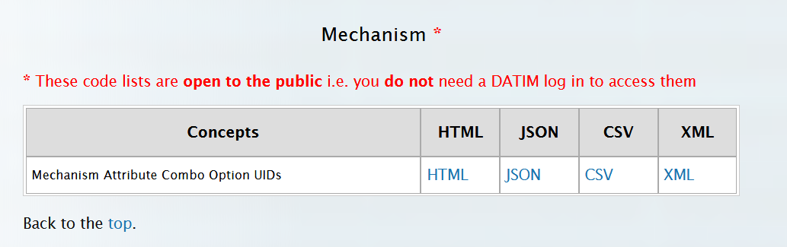 | 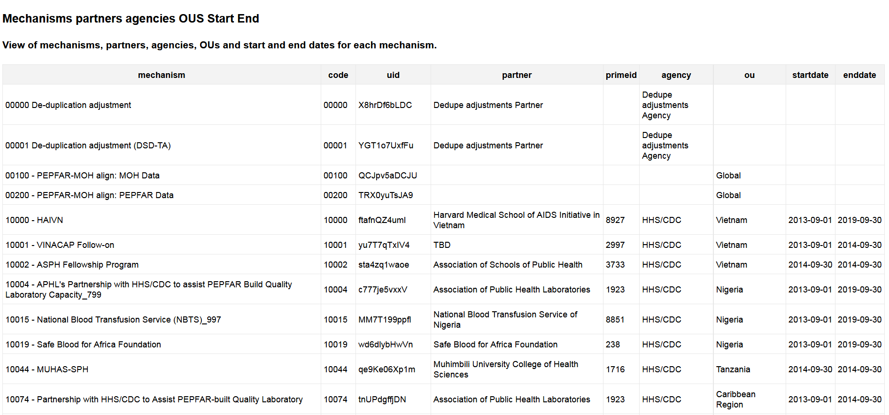

8 Example CSV files
- Using codes for data element and funding mechanisms:
Dataelement | period | orgunit | categoryoptioncombo | attributeOptionCombo | value | Comment | Storedby* | Timestamp*
SIMS.S_01_01_HIVQMQI_COMM | 20230101 | IHuZkWbFwNK | HllvX50cXC0 | 13559 | This is a sample data value | AssessmentXYZ
SIMS.A_01_01_HIVQMQI_Q1_RESP | 20230101 | IHuZkWbFwNK | HllvX50cXC0 | 13559 | 4 | AssessmentXYZ

- Same file using UIDs for both data element and funding mechanisms:
Dataelement | period | orgunit | categoryoptioncombo | attributeOptionCombo | Value | Comment | Storedby* | Timestamp*
kYY5KyDceYx | 20230101 | IHuZkWbFwNK | HllvX50cXC0 | nYb1tJnit15 | This is a  sample data value | AssessmentXYZ
lppMVnAcWF9 | 20230101 | IHuZkWbFwNK | HllvX50cXC0 | nYb1tJnit15 | 4 | AssessmentXYZ

*Optional fields

8.1 CSV Naming Convention
This section provides guidelines on the naming convention for the files being submitted for import.
Naming convention: agency_module_reportingperiod_versionnumber.csv
Agency | Abbreviation for participating agencies: hrsa, dod, usaid, and cdc
Module | SIMS modules include above site and site
Reporting period | For a file including assessment for the first quarter of fiscal year 2023 (October-December 2022), reporting period should be: fy23q1 (all letters should be lowercase).
Version number | The purpose of having a version number will help us identify if files are replaced during the data cleaning period, as well as track files if multiple submissions are required during the import process to address validation issues.  Initially, submitted files should all be labeled as v1.
Example: A user is uploading a file that contains the data for HRSA’s (agency) above site visits (module) for FY23 Q1 (reporting period). The naming convention will be as follows: hrsa_abovesite_fy23q1_v1.csv.
Additional notes:
- Use the three-character file extension: .csv
- Do not use special characters, such as . \ / : * ? “ < > |, except for underscores.
- Do not use spaces in the file name.
- All letters should be lowercase.
- As the size of the file can be large, compress the file
- The compressed (zipped) file can be used for import in DEV-DE (submit it as the CSV file), and also submitted through DATIM Support.

9 Data Import Testing
The implementing agency’s development team should thoroughly test the data import through DATIM’s data exchange testing (DEV-DE) environment. This is a dedicated server that is a copy of the actual DATIM production system. It is a testing environment that can be used to validate data prior to import into the production system without affecting the data stored in production.
Please note the following while testing in the DEV-DE environment:
- DO NOT conduct any testing in DATIM PROD.
- User credentials will be the same in DEV-DE as they are in DATIM.
- Data should only be submitted to the DATIM Support Team after you have successfully imported SIMS data into DEV-DE.
- Submitting data that have not been able to be imported into DEV-DE will lead to delays of your import.
- Although the exact number of values will vary based on the actual import, when importing data with the Import/Export module of DATIM, no conflicts should be present. If you receive any conflicts from the server, they should be resolved prior to submitting your data to the DATIM help desk for further validation. Note that a conflict relating to the header of the file, which is covered in Section 7 of this document, is expected and can be ignored.
- If code is used when importing the file, expand “More options” and select the appropriate schemes.

9.1 Validation Scripts
The implementing agency’s development team should perform validations testing using the R validation scripts provided by the DATIM Support Team. The validation scripts and instructions for how to set up and use them are at available at DATIM Support (https://datim.zendesk.com/hc/en-us/articles/115002334246-DATIM-Data-Import-and-Exchange-Resources).
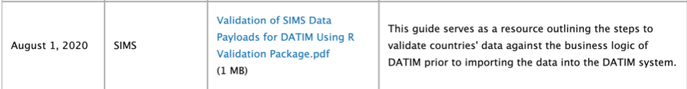
Note: New business rule validations will be added to the existing validations performed by the R validations script. These new checks will be used to filter out assessments that have incomplete coversheet data, wrong tool type, and invalid CEEs. Please refer to the guide in the image above for details.

9.2 Agency DEV-DE Testing Credentials
The following accounts have been enabled in the DEV-DE environment. Each participating agency has received the account credentials.
Participating Agency | Username | Account Custodian—SIMS System Lead
CDC | system_cdc_sims | Roma Bhatkoti
USAID | system_usaid_sims | Roney Akter
DOD | system_dod_sims | Ayesha Rashid
HRSA | system_hrsa_sims | Salem Gugsa

10 Submit the SIMS Data File for Import into DATIM
After validation and testing are successfully completed, the submission process begins. The following is a submission checklist for items required for submission of the SIMS data file for import into DATIM:
      - A validated and tested SIMS data file:
        - Include the format of the file (CSV, JSON, or XML); CSV is the preferred format
        - Include the coding scheme that has been used (UIDs or codes)
      - Include screenshots and outputs from successfully running validation scripts and testing of the SIMS import data file in DEV-DE:
        - The screenshot should show output from the DEV-DE environment, indicating that the data were imported without any conflicts reported from the server.
After you have the items listed above, proceed with communicating and submitting the SIMS file for import into DATIM.

10.1 Communicate Data Import File and Test Results to the DATIM Support Team
Submission of SIMS data files for import into DATIM production (datim.org) is done via DATIM Support. Please take the following steps to request import of your SIMS data into the DATIM production environment (datim.org).
As a reminder, the DATIM Support Team may be contacted at any time during this process if you have any questions.
- Navigate to datim.org and select the “DATIM Support” icon found under “Apps” in DATIM.
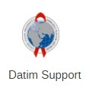
- Select “Submit a Request,” found in the Technical Support section.
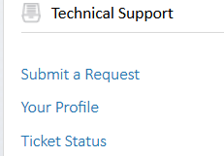
- This will take users to a new page where they can select a topic. From the dropdown menu, select “Data Import/Exchange.”
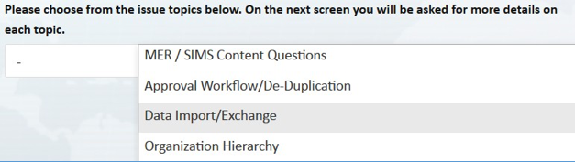
- After selecting “Data Import/Exchange,” additional questions will appear. Answer them accordingly, and be sure to complete the mandatory fields or the request cannot be submitted. Under “Description,” indicate the plan for importing data into DATIM and include a screenshot of the output from the DEV-DE environment, which shows that the data were able to be imported with no conflicts reported from the server and the outputs from running the validation scripts on the import file.
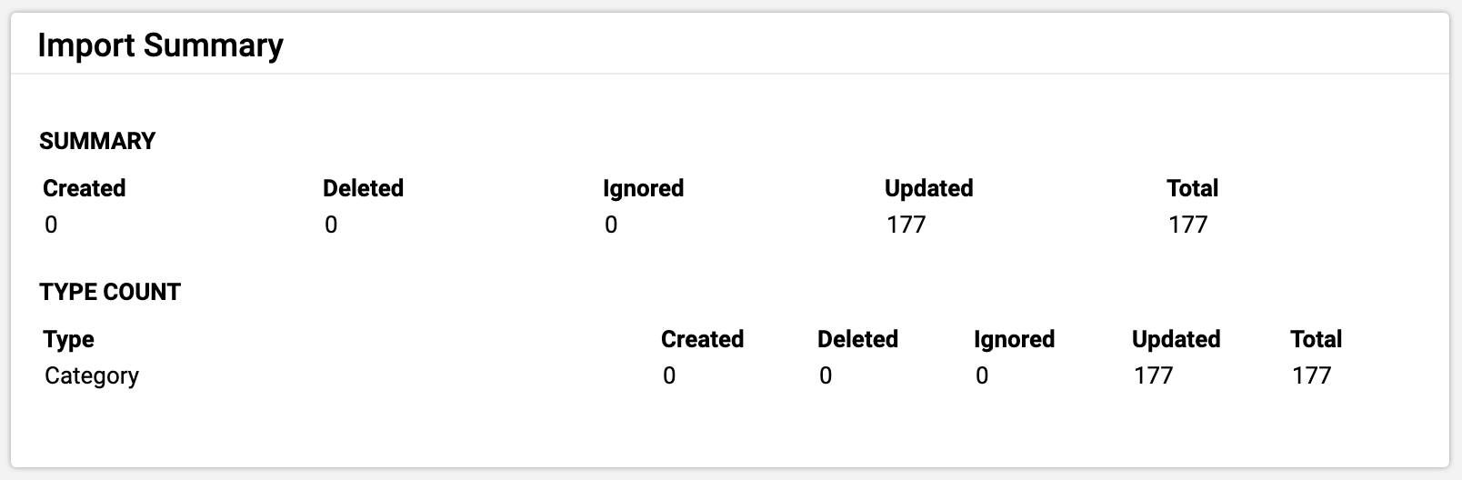
- Click on “Submit” when ready to send your request to DATIM Support.

10.2 SIMS Data Import into DATIM (Performed Exclusively by the DATIM Support Team)
Upon receiving your submission through the submitted DATIM support ticket, the DATIM Support Team will follow these steps:
- Test and validate the submitted SIMS data file using the same R Scripts and server (DEV-DE). If any issues are detected, the file will not be imported.
  - The agency will be notified of testing validation issues and will need to take corrective action to address validation issues flagged by the DATIM Support Team.
  - After the agency has corrected these issues, it will need to repeat the above process with the newly corrected import file (i.e., revalidate, retest, and resubmit).
- After all validation and testing issues have been verified as fixed by the DATIM Support Team, the file will be ready for import into DATIM production. The import into DATIM production will be performed by the DATIM Support Team, which will provide the agency with a timeline for when the file will be imported into DATIM production.
- Upon receipt of approval from the S/GAC Team Lead, the DATIM Support Team will import the SIMS data file into DATIM.
- The DATIM Support Team will inform the agency and provide import feedback after the import is complete and proceed to close the support ticket.

11 DATIM’s Policy and Process for Managing Organizational Hierarchy Changes
DATIM has established a policy and process for handing organizational hierarchy changes. These types of changes originate from requests submitted by a country’s site administrator. The DATIM organizational hierarchy change policy requires getting approval from each country’s PEPFAR Program Manager and informing the PEPFAR Chair and Country Lead in a DATIM Support Ticket before these changes can be completed in DATIM. Organizational hierarchy changes can include the following site operations in DATIM:
- Adding sites
- Relocating or merging sites
- Deleting sites
- Renaming, editing, or updating sites
Note that adding and editing of existing sites (such as changing a name, code, or coordinates, but not relocating, deleting, or merging) can also be done by country site administrators without explicit notification to DATIM team.
Details of the policies and process steps associated with each type of organizational hierarchy change are available on DATIM support page (https://datim.zendesk.com/hc/en-us/articles/211856726-Organization-Hierarchy-Templates), including templates and instructions on how to request these changes. A valid DATIM login is required to access this page.
Only deletion and relocation operations have a significant impact on existing SIMS assessments associated with the sites already in DATIM. These are handled as per the organizational hierarchy policy and process, as described in the sections that follow.

11.1 Deleting Sites
It should be noted that sites cannot be deleted from DATIM if they have SIMS or MER data associated with them. If the DATIM Support Team receives a request to perform a site deletion, the team will investigate whether there are existing data associated with the site marked for deletion. If data are associated with the site, the DATIM Support Team will notify the country site administrator to move the data to an appropriate site (i.e., a Receptor site) and then perform the processes outlined for site relocation prior to deleting the site. After the data have been relocated to the Receptor site and no data exist at that site, the site will be deleted from DATIM.

11.2 Relocating or Merging sites
These two site operations can only be performed by the DATIM Support Team; technically, however, SIMS data cannot be merged because SIMS data are assessment data collected on a daily basis, unlike MER data, which are aggregate data. After the DATIM Support Team receives a request to perform a site relocation, the SIMS assessment data are moved to the Receptor site. For most relocation requests, the SIMS assessment moves to the Receptor site seamlessly. In very rare cases, however, a collision may occur, which happens if the assessment being moved to the Receptor site has the same period and funding mechanism as an already existing SIMS assessment already associated with the Receptor site. In the event of a collision, the DATIM Support Team will communicate inform the country team of remediation steps that will be taken to avoid a collision, and will then complete the relocation of the SIMS assessment. To remediate a collision, the DATIM Support Team applies an offset value to the period, typically by moving it one day over for the assessment being moved, thus resolving the collision and allowing for the move to the Receptor site to be completed.

11.3 Communicating Organizational Hierarchy Changes to Agency Stakeholders
The DATIM Support Team communicates on a weekly basis via email (see sample email below) to all SIMS agency points of contact detailing the organizational hierarchy changes that have been completed in DATIM.
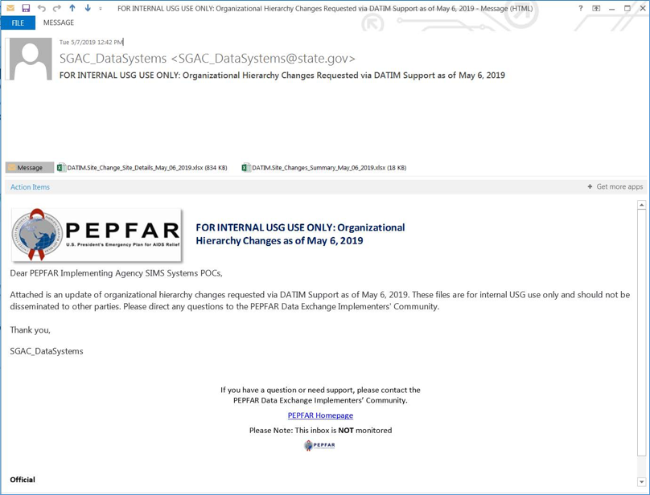

12 Resources
Several reference and guidance materials further explaining DATIM data imports are available on the DATIM Support page under the Data Import and Exchange page, including detailed guidance on how to download and use the R Script.
SIMS stakeholders are also encouraged to participate in the PEPFAR Data Exchange Implementer Community call. The PEPFAR Data Exchange Implementer Community page contains details on upcoming call dates and agenda items, previous call recordings and notes, and call-in details, as well as information on how to sign up for the PEPAR Data Exchange listserv.
Participating agencies are also encouraged to document the processes undertaken and resources used in the data import effort to help drive knowledge sharing, lessons learned, and process improvements. This may include the following:
- Structured coordination of importing efforts
- Resources for the process (time, expertise, human)
- Documentation for data mapping, instructions, or rationale for mapping
- Process for test file creation
- Data import test plan and results
- Long-term data import/exchange strategy for phased implementation
- Ongoing documentation of challenges and lessons learned
Consider time for corrective action, planning, and updating these processes, as they are considered iterative. The documents created and used by the participating agencies can be leveraged and serve as great resources for others. Agencies with well-documented and set processes should consider sharing their resources.

